**Design Document**

**Monsters Inc.**

**Jaime Aughney**

**C00136162**

**1. Overview of the game**

* The genre of the game is an RPG tower defence game. The setting is in a city where all kinds of monsters have invaded through a time portal.
* The player controls the humans he tells them to defend or go build towers. The player can control one human on the field, move around and shoot monsters or shoot from the base.
* The aim of each level in the game is to not die and kill all of the monsters in the level. The player can hide in the base then defend the base and not let the monsters destroy it. If the monsters destroy the base they will then come for the player. The player can still complete the level if the base is destroyed as long as the player doesn’t die.
* Games that have influenced my game:
  + Defender for Android.

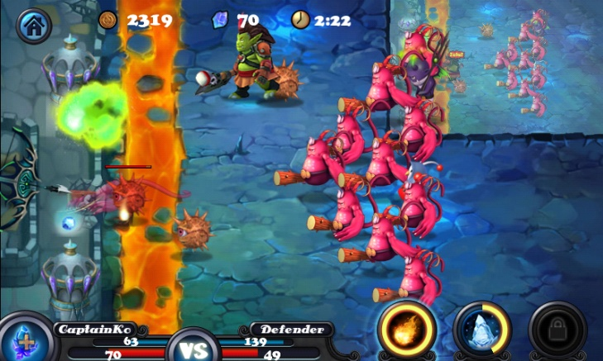

This is a tower defence game where your base is at the left side of the screen and the enemies come from the right side of the screen and you have to shoot them by touching where you want to shoot before they destroy the base. You can upgrade your weapons with coins that you get from killing enemies. From this game I have taken the idea of having a base at the end of the screen, shooting the enemies from the base and the ability to upgrade your weapons with coins that you collect from killing the enemies.

* Age of Zombie for android and iPad.

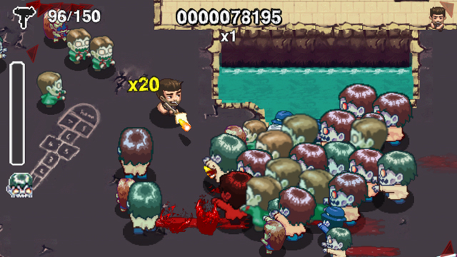

In this game you control a human and run around the map shooting zombies and pick up better guns. You put your two thumbs on the tablet and it makes to analogues under your thumbs you use your left thumb to move the human and the right thumb is to fire in the direction that you’re pointing. From this game I have taken the idea of controlling the character on the map and shooting zombies with two virtual analogue sticks when you put your thumbs on the tablet.

* Desktop Tower Defence for pc.

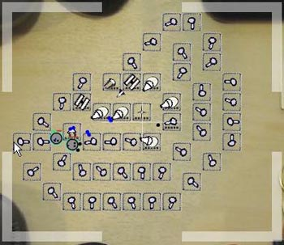

This is a tower defence game were you can place your turrets anywhere on the map. The idea is to make a path for the enemies to walk along so it takes them longer to get to their goal and you have more time to try killing them. You can make any path you want you just cannot block the enemies. From this game I have taken the idea of placing your turrets where you like so you can create a path for the enemies to walk along.

* The last stand 2 for pc.

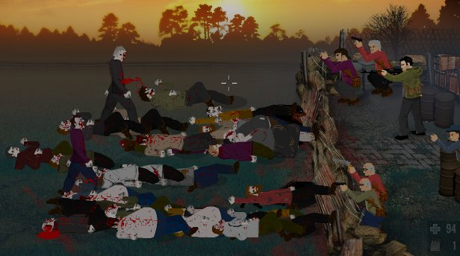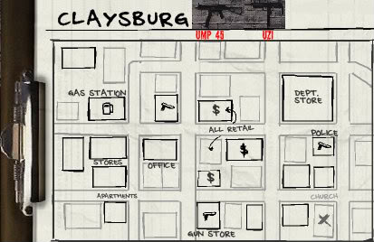

This game is allot like Defender for Android. You have a base at one side of the screen and zombies come from the other side of the screen. You have guns and you have to kill them to complete the level. At the end of each level you have a certain amount of hours to do tasks. You can fix damage done to your base or you can go looking in different building for supplies, guns and survivors. From this game I am taken the idea of having a certain amount of time after every level and having the choice to do different tasks like looking for other survivors, looking for supplies.

* My game is unique because it is a mix between RPG and tower defence games. You have the choice of running around the map shooting monsters like an RPG or shooting them from the base like a tower defence game. You have to build your towers with humans. They have to be at the position where you want the tower and building the tower takes a certain amount of time. When the human is building the tower you have to defend him until he has the tower built or the monsters will kill him.

**2. Game Mechanics**

2.1 Space

* + The game will be 2 dimensional and will be played on an iPad held sideways (landscape).
  + Each map will be the height of the screen and the width if the map will depend on the level. Harder levels will be longer maps.
  + The player can move anywhere in this map but can’t move outside it. When the player moves to the base the user can select it by touching it then select enter then the player will be inside the base. The player cannot move around in the base he can only shoot.
  + At the end of each level there will be a menu where the user can upgrade his weapons, towers or the base. The user can also use the time he has to search for supplies, survivors or guns.

2.2 Objects

* + Map
    - Attributes: width, height,
  + Player
    - Attributes: current life, Max life, current speed, max speed, gun equipped, Coin Amount, defence.
    - States: alive-dead, shooting, moving, building, repairing the base
  + Human
    - Attributes: current life, max life, current speed, max speed, defence, gun equipped
    - States: alive-dead, shooting, moving this is when the human is walking to build a tower or walking back to the base after building a tower, building, repairing the base, idle this is when the human is in the base but not doing anything
  + Monster
    - Attributes: current life, Max life, current speed, Max speed, attack damage, defence
    - States: alive-dead, attacking-moving-chasing these states depend if the player is on the map or in the base. If the player is on the map then the monsters are chasing the player. If the player is in the base then the monsters are moving towards the base. if the monster is either close to the player or close to the base then the monster is attacking
  + Base
    - Attributes: current life, max life, defence,
    - States: alive-dead
  + Gun
    - Attributes: ammo left, ammo in clip, damage, fire rate, reload rate, fire distance, accuracy
    - States: shooting-not shooting-reloading-empty
  + Defence Tower
    - Attributes: damage, fire rate , fire distance,
    - States: firing-not firing, built-not build this state changes when the player builds the tower. If the human dies during building the tower it is not built and another human has to finish building it
  + Shop menu. This is the menu seen after each level.
    - Attributes: coin amount, gun upgrades, base upgrades, upgrade cost
    - States: shown –not shown, upgrade unlocked-upgrade locked, upgrade bought-upgrade not bought
  + Main menu
    - Attributes: start game, options, load game
    - States: shown-not shown

2.3 Actions

* Shoot
  + The player or human shoots his gun.
* Run
  + The player moves around the map or a human is moving on the map.
* Protect
  + The player protects a human while the human is building a tower.
* Build
  + The player or a human is building a tower.
* Repair
  + The player or a human is repairing the base.

2.4 Rules

* The player cannot move outside the map
* When the player is placing towers he cannot block the monsters path to the base
* You cannot place two towers on the same position or on top of another tower
* The monsters cannot walk through the towers they must walk around them

2.5 Skills

* The player must be a fast tinker. He must be able to think of doing multiple tasks and think what needs to be done next. Building turrets every time you have money to create a successful enough path that will slow down the monsters. This must be done fast before to many monsters come and the player won’t be able to build them.
* The player must be familiar with analogue controls to control the player.

2.6 Chance

* The number of monsters is different in every level and will be different if you play the same level twice e.g. level 1 :50-100 monsters, level2: 100-200 monsters
* The numbers of monsters on screen at once will be different. One might spawn every second or even 5 seconds. 5 monsters could even spawn every second until the number of monsters in that level is reached.
* When the player is searching for supplies or guns or survivors he might not find any. Each place will have a likeliness of finding something but not a guarantee e.g. survivors are more likely to be found in a hospital than graveyard and guns are more likely to be found in a gun shop than a hospital.
* The health and defence of each monster will also be random between certain numbers, health: 45-60. Defence: 4-9

**3. User Story**

**Title:** As the user I can move the player around the screen

**Conditions of satisfaction:**

* I can see the player moving on the screen
* I am able to easily control the player and tell him where to go on the screen

**Story Board:**

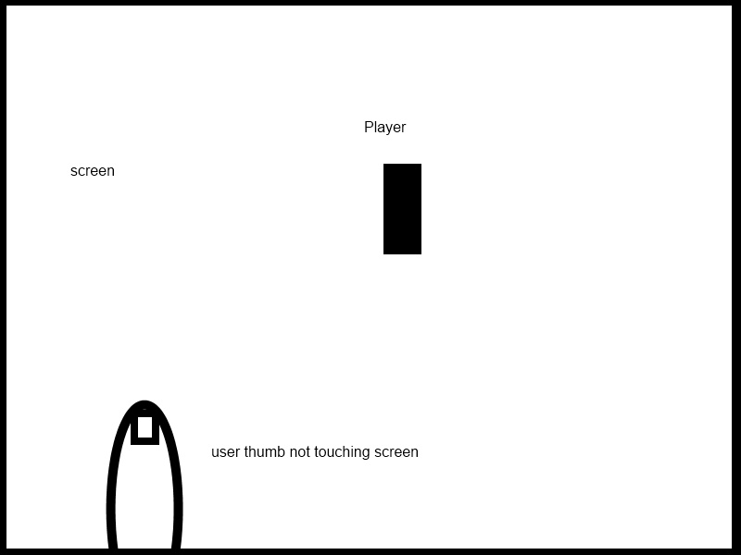

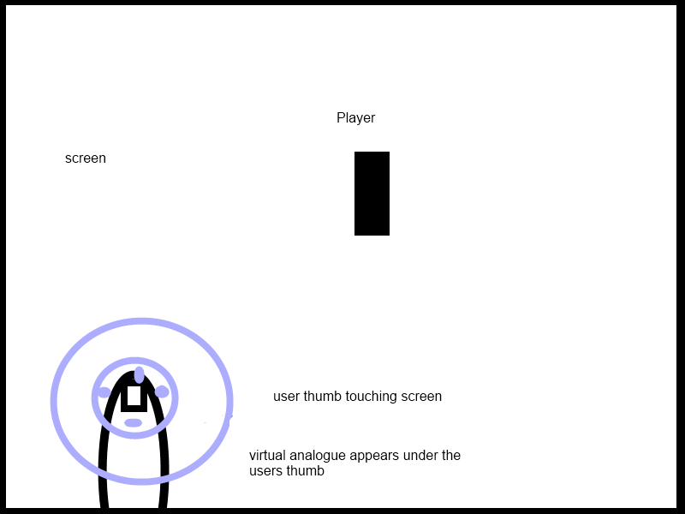

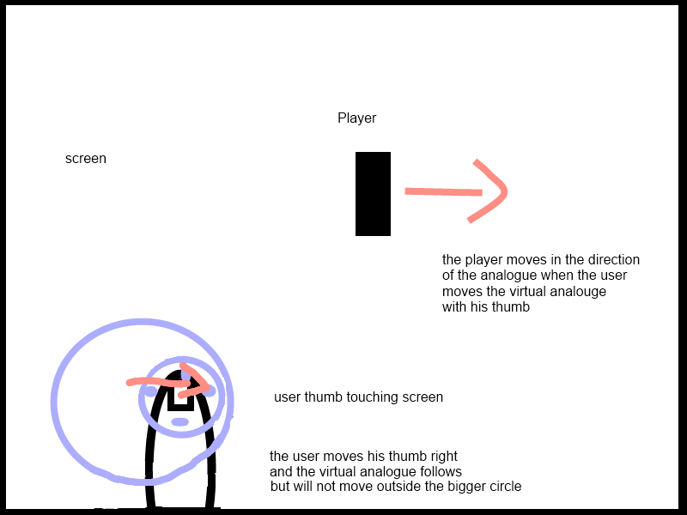

**Title:** as the user I can make the player shoot the enemies.

**Conditions of satisfaction:**

* The player shoots his weapon
* The player shoots in the direction I want him to
* The player starts and stops shooting when I tell him to.

**Storyboard:**

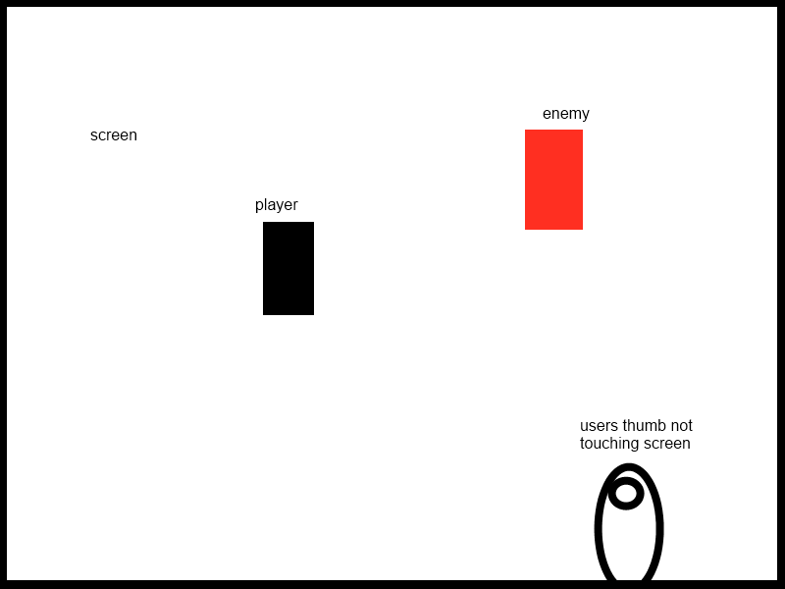

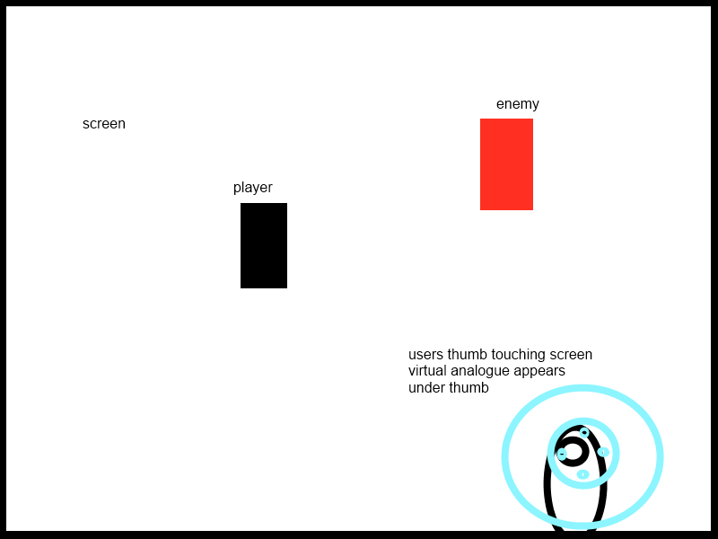

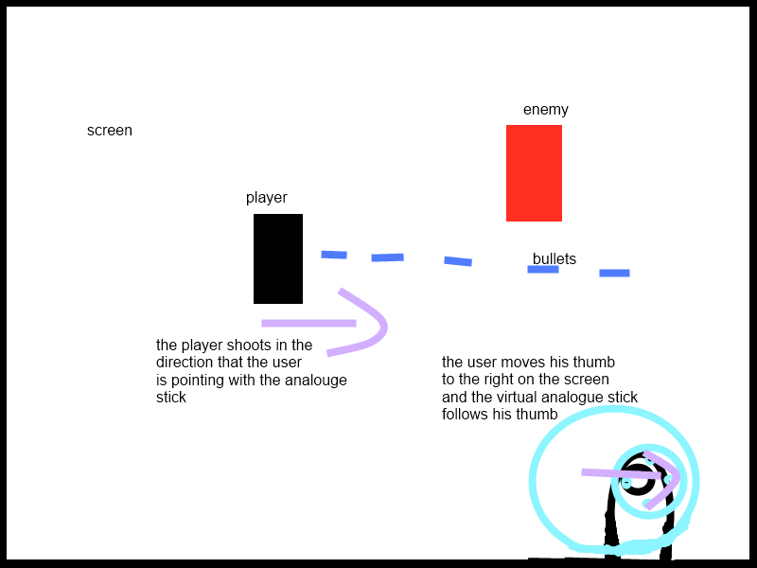

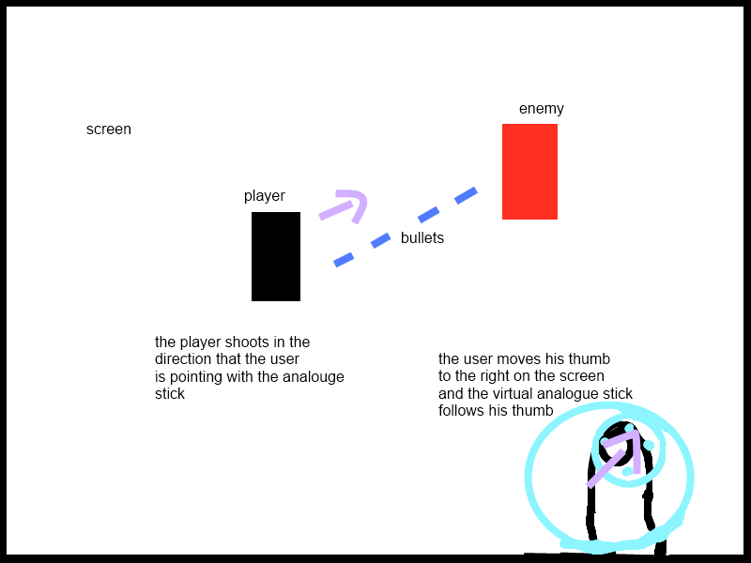

**Title:** As the user it should be clear how to switch the player’s weapons.

**Conditions of satisfaction:**

* I can see clearly how to change weapons
* I can clearly see what weapon the player has currently equipped

**Storyboard:**

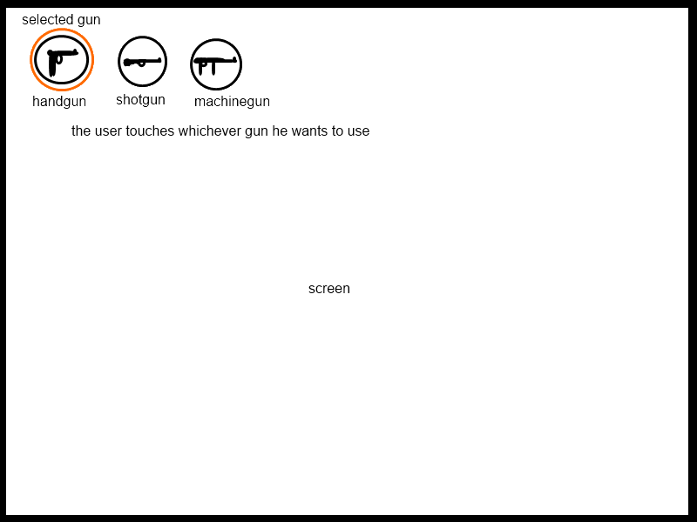

**Title:** As the user I can build towers where I want on the map

**Conditions of Satisfaction:**

* I can choose the tower I want to build
* I can choose where I want to build the tower
* A human runs out and builds the tower at that position

**Storyboard:**

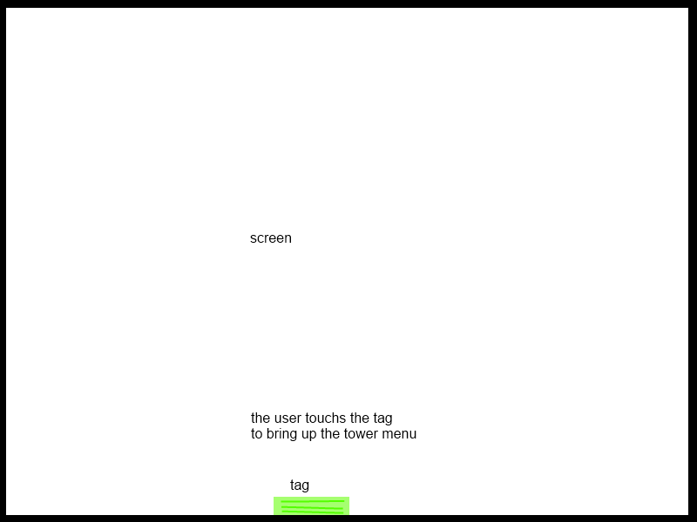

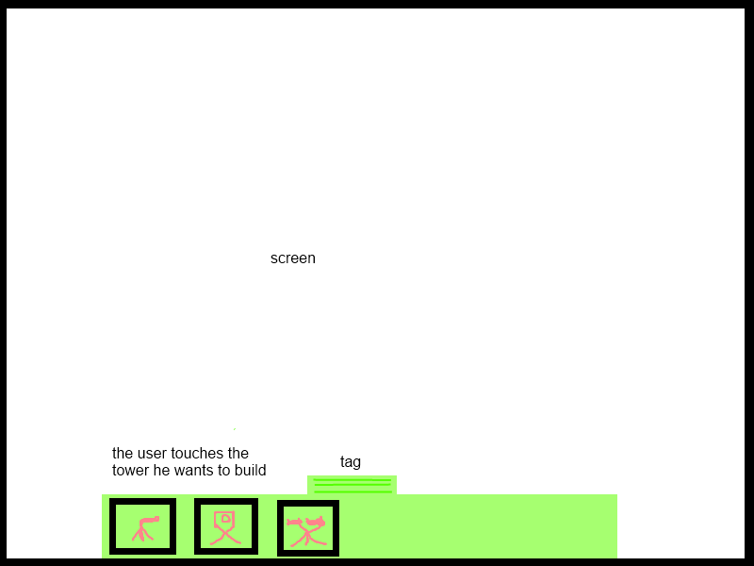

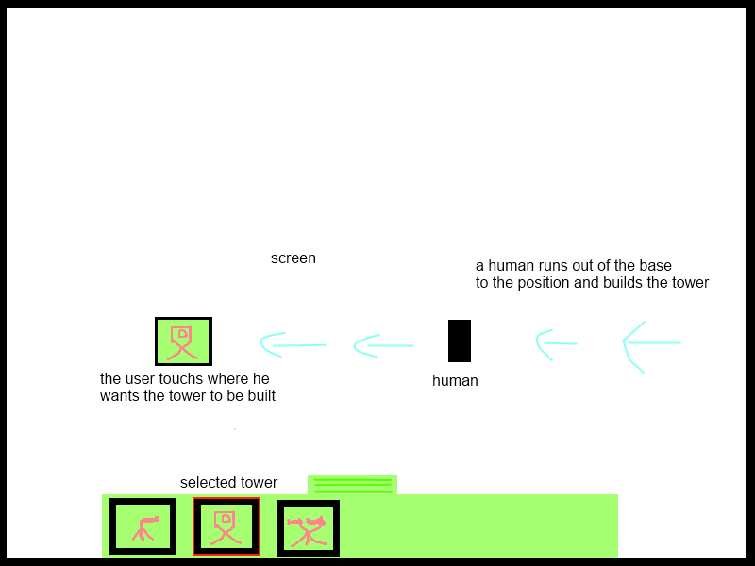

**Title:** As the human I can get to the position where the tower needs to be built

**Conditions of satisfaction:**

* I can get to the position
* The path to my position is not blocked
* I can move around any obstacles in direct rout of the position

**Story Board:**

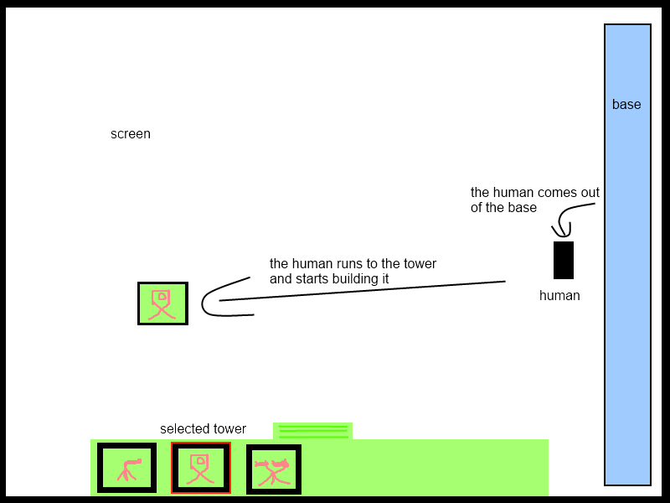

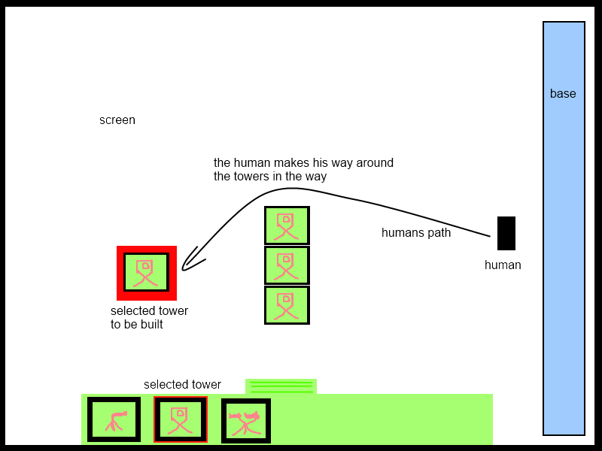

**Title:** As the enemy I can move to the base and attack it

**Conditions of Satisfaction:**

* The enemy walks to the base on the shortest path
* The enemy walks around any obstacles
* The enemy attacks the base

**Story board:**

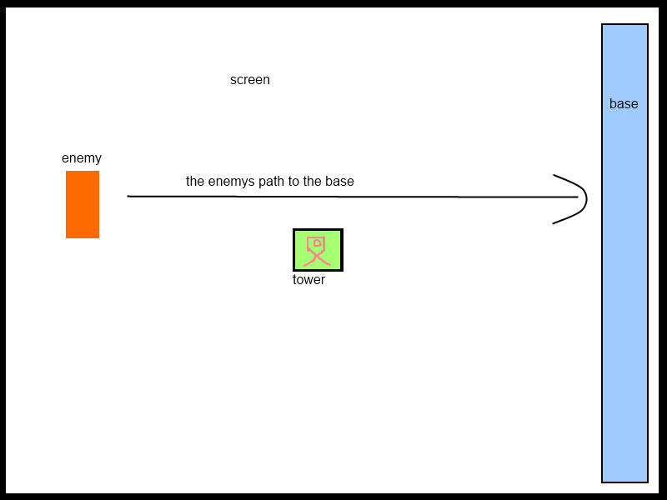

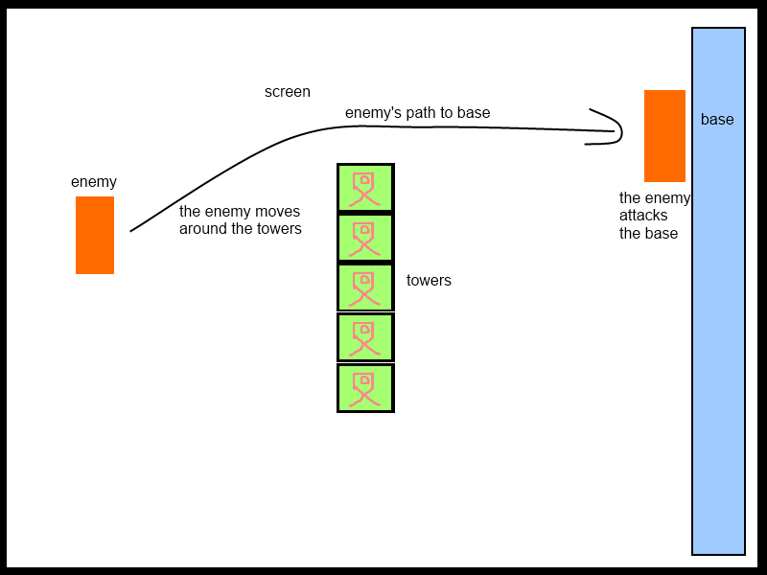

**Title:** As the tower I can attack an enemy when it gets in my attack radius

**Conditions of Satisfaction:**

* The tower sees the enemy in its range
* The tower attacks the enemy
* When the enemy exits the tower range the tower stops attacking it

**Story Board:**

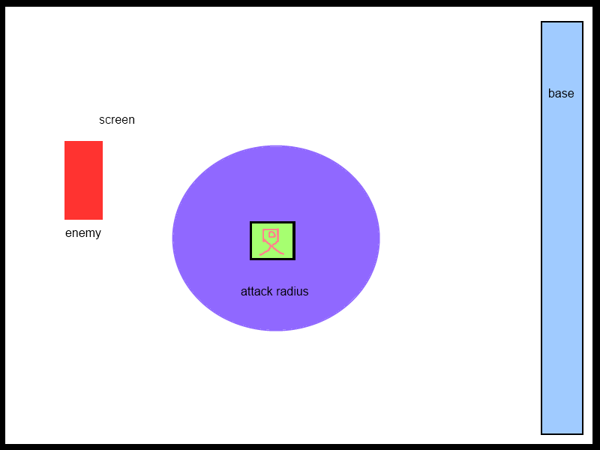

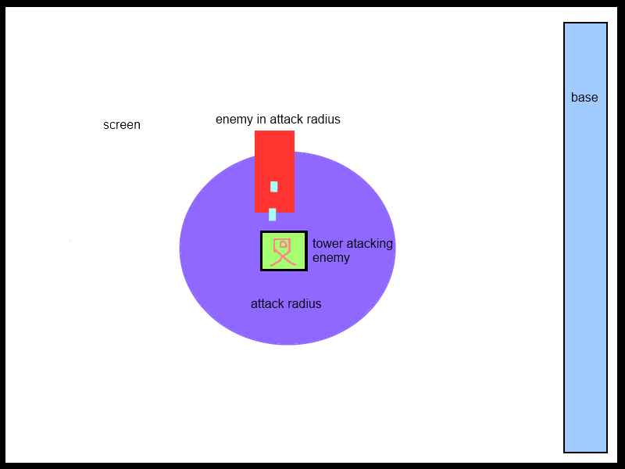

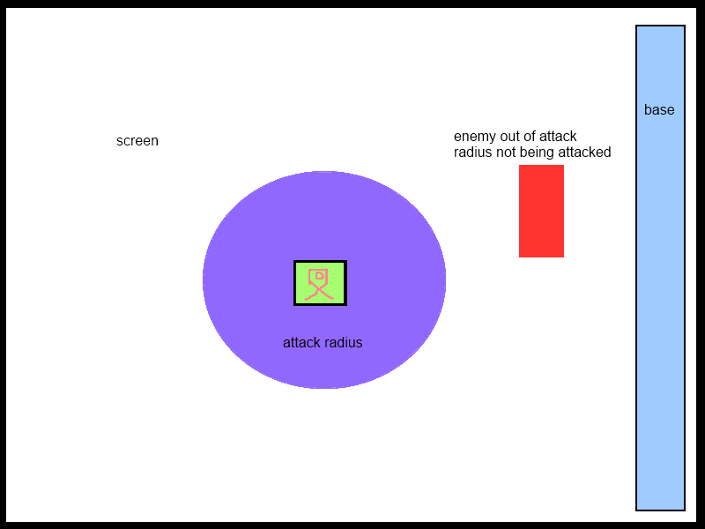

**Title:** As the base I can show the user how many humans are in the base

**Conditions of Satisfaction:**

* The base shows a menu when touched by the user
* The menu shows the humans in the base

**Story Board:**

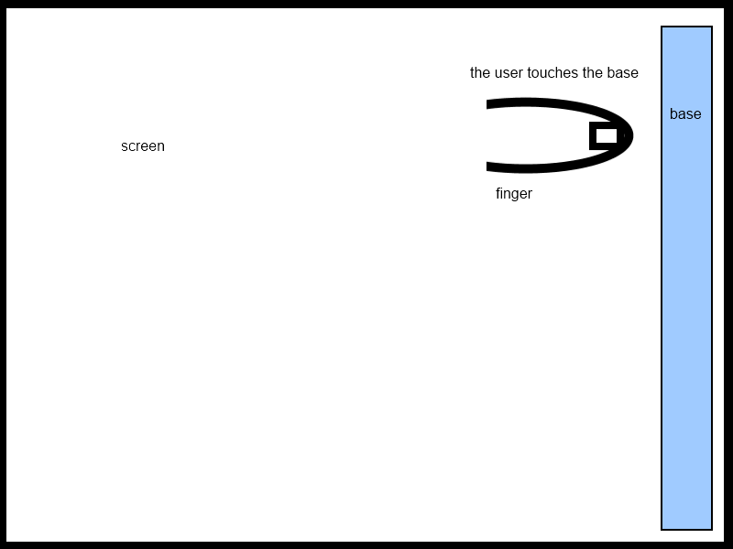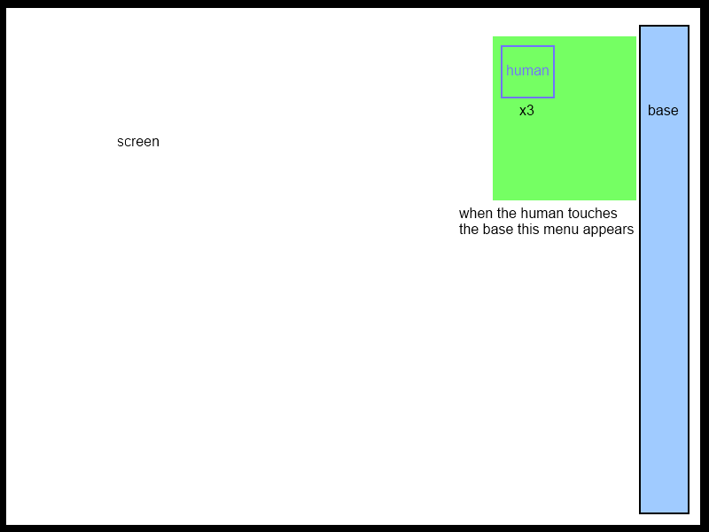

**Title:** As the user I can tell the humans what to do

**Conditions of Satisfaction:**

* The user touched the humans in the menu
* A menu appears that has actions for the human to do
* The user selects one of these actions

**Story Board:**

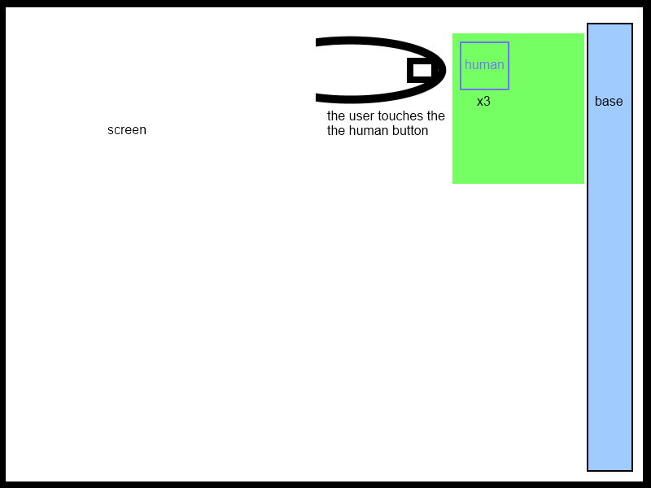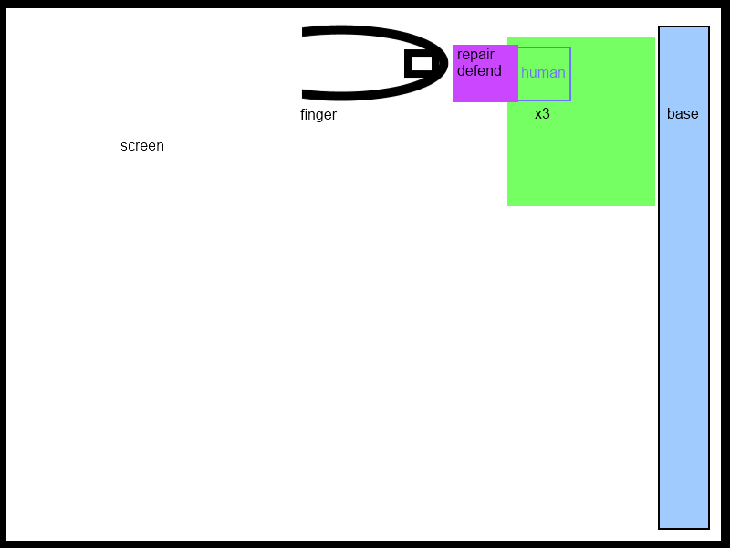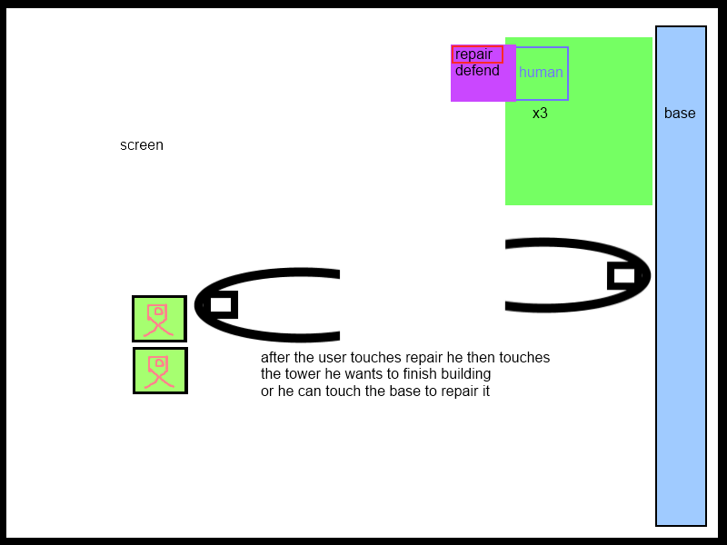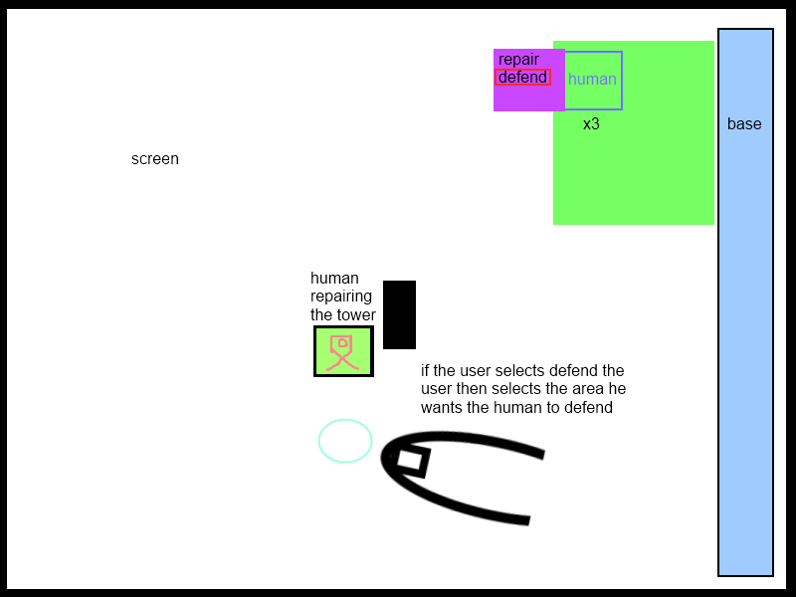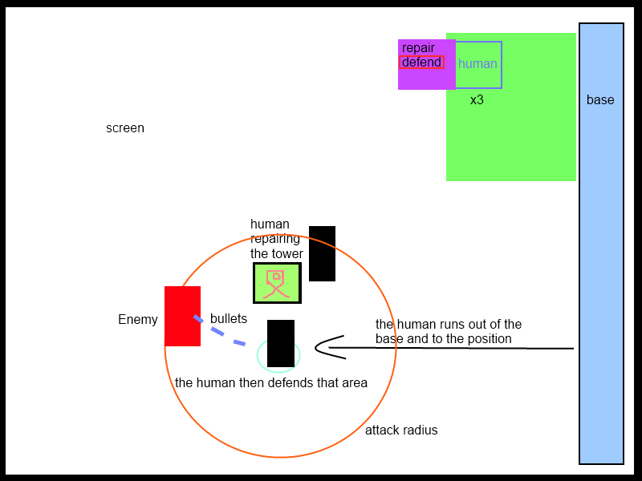

**Title:** As the user I can complete each level

**Conditions of satisfaction:**

* All the monsters in the level are destroyed
* The player is still alive
* The base is not destroyed

**Title:**  As the user I can upgrade my weapons and defences at the end of every level

**Conditions of Satisfaction:**

* The upgrade menu appears after the level ends
* I can upgrade my weapons and defences with money that I got from killing enemies

**Storyboard:**

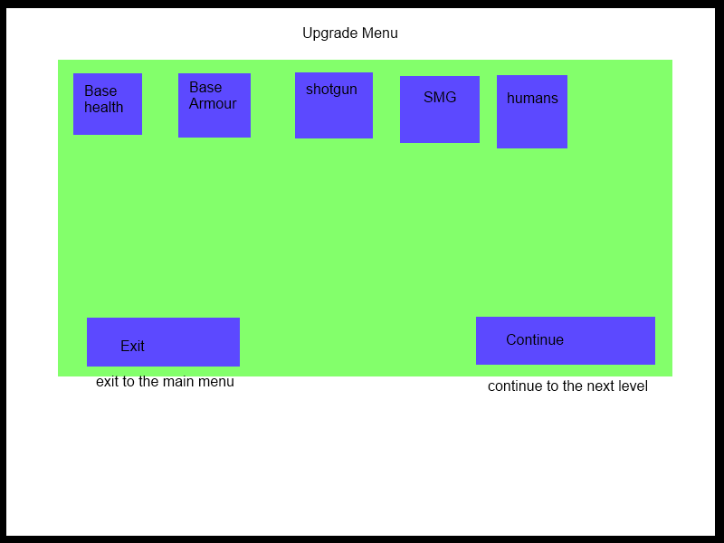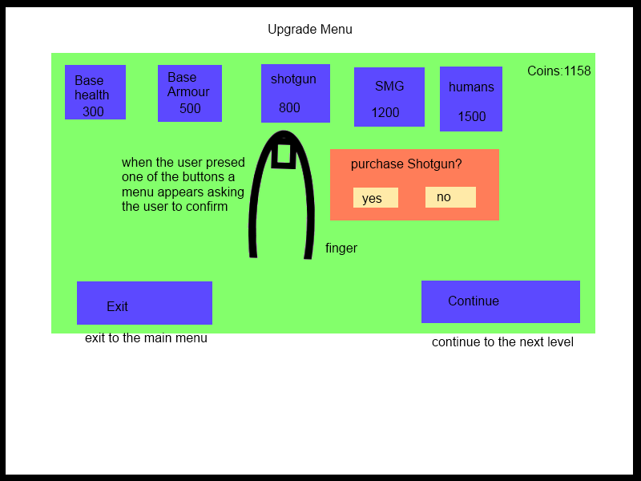

**Title:** As the user I can Scroll the screen left or right

**Conditions of Satisfaction:**

* The user can scroll the screen left or right using two fingers

**Story Board:**

